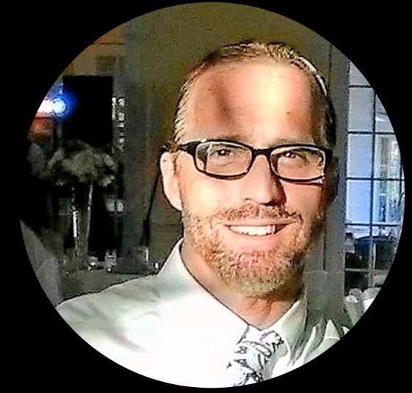

Michael Jett Adams, BS NHA Bio:

Licensed Nursing Home Administrator in the State of Florida since 1998. Graduated from Southern Adventist University with a Bachelor’s In Long-term Health Care Administration. I am licensed in Florida and Indiana. Currently leading the operations for the health care unit at Courtenay Springs Village in Merritt Island Florida. Courtenay offers 96 skilled and rehabilitation care beds and a 180 unit Independent Living tower.

Since staring service in Florida I have served mostly in skilled rehabilitation centers along the eastern coast of Florida. I have been a part of 5 full scale facility hurricane evacuations and 1 ‘shelter’ facility in the last 15 years. I have worked very closely with the Brevard County Emergency Operations Center and most recently the Lake County Emergency Operations Center where my facility received over 50 residents and employees from the Panama City area following Hurricane Michael. I have worked closely with local hospitals, service providors, transportation companies and of course my care teams to make these events successful. I look forward to offering some of my experience and dedication to protecting our seniors here in Central Florida.

MJA

