Off the Rails

2023 Region 5 Mass Casualty Full Scale Exercise

April 20, 2023

Exercise Plan
Draft 3-9-23

The Exercise Plan (ExPlan) gives elected and appointed officials, observers, media personnel, and players from participating organizations information they need to observe and/or participate in the exercise. Some exercise material is intended for the exclusive use of exercise planners, controllers, and evaluators, but players may view other materials that are necessary to their performance. All exercise participants may view the ExPlan.

EXERCISE OVERVIEW

Exercise Name | Off the Rails
Exercise Dates | April 20, 2023
Scope | This exercise is a Full-Scale Regional Exercise, planned for 4 hours at 60 hospitals in nine counties.
Mission Area(s) | Protection & Response
Core Capabilities | Hospital Preparedness Program Capabilities:  Capability 1. Foundation for Health Care and Medical Readiness Capability 2: Health Care and Medical Response Coordination Capability 3: Continuity of Health Care Service Delivery Capability 4: Medical Surge
Objectives | See Page 4 Table 1. Exercise Objectives and Associated Core Capabilities
Threat or Hazard | Intentional – Train Derailment
Scenario | A known terrorist group has been posting numerous threats in the weeks prior to today. They claim to seek vengeance for perceived wrongs and promise 4/20 will be celebrated differently after today. FBI alert warns of transit targets with no specifics.  Beginning at 8:01 am reports from across the region begin with multiple reports of train related incidents
Sponsor | Central Florida Disaster Medical Coalition
Participating Organizations | There will be approximately 1783 live victim and family member volunteers from schools across the region. There are approximately 100 agencies participating (FBI, FDLE, local law enforcement, local fire/rescue/EMS, etc.)

Point of Contact | Exercise Director:  Lynne Drawdy info@centralfladisaster.org (407) 928-1288  Senior Exercise Planner:  Amanda Freeman  Amanda.freeman@adventhealth.com  (321) 438-7143  Exercise Coordinator: Matt Meyers Matt.Meyers@flhealth.gov (407) 908-0142  Planning Team Members:

GENERAL INFORMATION

Exercise Objectives and Core Capabilities
The following exercise objectives in Table 1 describe the expected outcomes for the exercise. The objectives are linked to core capabilities, which are distinct critical elements necessary to achieve the specific mission area(s). The objectives and aligned core capabilities are guided by elected and appointed officials and selected by the Exercise Planning Team.

Exercise Objective | Core Capability
Objective 1: Evaluate the hospitals’ ability to demonstrate Hospital Incident Command System (HICS) in response to a major incident.  Objective 2: Assess hospital facilities ability to activate and implement infrastructure protection measures in response to a major incident in accordance with policies and procedures.  Objective 3: Evaluate hospital facilities ability to activate and execute decontamination, triage, medical surge, and resource management in response to a major incident in accordance with policies and procedures.  Objective 4: Assess community partners’ ability to share and receive timely communications to support security and assist with situational awareness and operational decisions during an incident in the community, utilizing the communications platforms available within the region.  Objective 5: Capture data and information on hospital fatality management during the exercise.  Objective 6: Demonstrate capability to connect county EOCs with local hospitals and EOC to EOC interconnectivity.  Objective 7: Test acute care hospital and free-standing emergency departments’ capability to stabilize and/or treat high number of burn patients.  Objective 8: Demonstrate and exercise the regional hazardous material response plan.  Objective 9: Assess community partners’ ability to share and receive timely communications to support security and assist with situational awareness and operational decisions during an incident in the community. | ASPR HPP Capability #2: Healthcare and Medical Response Coordination  ASPR HPP Capability #3: Continuity of Healthcare Service Delivery  ASPR HPP Capability #4: Medical Surge  ASPR HPP Capability #2: Healthcare and Medical Response Coordination  ASPR HPP Capability #4: Medical Surge  ASPR HPP Capability #2: Healthcare and Medical Response Coordination  ASPR HPP Capability #4: Medical Surge  ASPR HPP Capability #2: Healthcare and Medical Response Coordination  ASPR HPP Capability #2: Healthcare and Medical Response Coordination

Participant Roles and Responsibilities
The term participant encompasses many groups of people, not just those playing in the exercise. Groups of participants involved in the exercise, and their respective roles and responsibilities, are as follows:
- Players. Players are personnel who have an active role in discussing or performing their regular roles and responsibilities during the exercise. Players discuss or initiate actions in response to the simulated emergency.
- Controllers. Controllers will plan and manage exercise play, set up and operate the exercise site, and act in the roles of organizations or individuals that are not playing in the exercise. Controllers direct the pace of the exercise, provide key data to players, and may prompt or initiate certain player actions to ensure exercise continuity. In addition, they issue exercise material to players as required, monitor the exercise timeline, and supervise the safety of all exercise participants.
- Simulators. Simulators are control staff personnel who role play nonparticipating organizations or individuals. They most often operate out of the Simulation Cell (SimCell), but they may occasionally have face-to-face contact with players. Simulators function semi-independently under the supervision of SimCell controllers, enacting roles (e.g., media reporters or next of kin) in accordance with instructions provided in the Master Scenario Events List (MSEL). All simulators are ultimately accountable to the Exercise Director and Senior Controller.
- Evaluators. Evaluators evaluate and provide feedback on a designated functional area of the exercise. Evaluators observe and document performance against established capability targets and critical tasks, in accordance with the Exercise Evaluation Guides (EEGs). See also C/E Handbook
- Actors. Actors simulate specific roles during exercise play, typically victims or other bystanders. Actors will be termed volunteer victims for this exercise.
- Observers. Observers visit or view selected segments of the exercise. Observers do not play in the exercise, nor do they perform any control or evaluation functions. Observers view the exercise from a designated observation area and must remain within the observation area during the exercise. Very Important Persons (VIPs) are also observers, but they frequently are grouped separately.
- Media Personnel. Some media personnel may be present as observers, pending approval by the sponsor organization and the Exercise Planning Team.
- Support Staff. The exercise support staff includes individuals who perform administrative and logistical support tasks during the exercise (e.g., registration, catering).

Exercise Assumptions and Artificialities
In any exercise, assumptions and artificialities may be necessary to complete play in the time allotted and/or account for logistical limitations. Exercise participants should accept that assumptions and artificialities are inherent in any exercise and should not allow these considerations to negatively impact their participation.

Assumptions
- The exercise will be conducted in a no-fault learning environment wherein systems and processes, not individuals, will be evaluated
- Exercise simulation will be realistic and plausible and will contain sufficient detail from which players can respond
- Exercise players will react to information and situations as they are presented, in the same manner as if the simulated incident were real

Artificialities
During this exercise, the following artificialities apply:

Exercise communication and coordination will be limited to participating
exercise venues
- Only communication methods listed in the Communications Plan will be available for players to use during the exercise.
- Participating agencies may need to balance exercise play with real-world emergencies. Real-world emergencies will take priority.
- All emergency response assets will be pre-staged in designated assembly areas (at hospitals).
- The exercise will be played in real time; however, some time intervals may be sped up to accommodate schedules and meet exercise objectives.

EXERCISE LOGISTICS

Safety
Exercise participant safety takes priority over exercise events. The following general requirements apply to the exercise:
- Exercise Controllers and Evaluators are responsible for participant safety; any safety concerns must be immediately reported to the Exercise Planning Team. The Exercise Planning Team will determine if a real-world emergency warrants a pause in exercise play and when exercise play can be resumed.
  - Exercise Controllers/Evaluators will vocalize the term “Freeze” to stop any potentially unsafe exercise play.
  - Volunteer Victims are to wear masks throughout the duration of the exercise.
- Hospital decontamination teams will not get volunteer victim (role players) wet.
- For an emergency that requires assistance, use the phrase “real-world emergency.” The following procedures should be used in case of a real emergency during the exercise:
- Anyone who observes a participant who is seriously ill or injured will immediately notify emergency services and the closest controller, and, within reason and training, render aid.
- The controller(s)/evaluator(s) aware of a real emergency will initiate the “real- world emergency” broadcast and provide the Exercise Planning Team with the location of the emergency and resources needed, if any. The Exercise Planning Team will notify the County SimCell as soon as possible if a real emergency occurs.

Fire Safety
Standard fire and safety regulations relevant to each participating location will be followed during the exercise.

Emergency Medical Services
The sponsor organizations will coordinate with local emergency medical services in the event of a real-world emergency.

Electrical and Generating Device Hazards
All applicable electrical and generating device safety requirements should be documented prior to the start of the exercise.

Weapons Policy
All participants will follow the relevant weapons policy for the exercising organizations.

Site Access

Security
If entry control is required for the exercise venue(s), the sponsor organizations are responsible for arranging appropriate security measures. To prevent interruption of the exercise, access to exercise sites is limited to exercise participants. Players should advise their venue’s controller or evaluator of any unauthorized persons.

Media/Observer Coordination
Organizations with media personnel and/or observers attending the event should coordinate with the sponsor organization for access to the exercise site.
Media/Observers are escorted to designated areas and always accompanied by an exercise controller. Sponsor organization representatives and/or the observer controller may be present to explain exercise conduct and answer questions. Exercise participants should be advised of media and/or observer presence.

Exercise Identification
Exercise staff may be identified by badges, hats, and/or vests to clearly display exercise roles; additionally, uniform clothing may be worn to show agency affiliation.

Exercise Participant T-Shirts are all (TBD) with logo on the front:

POST-EXERCISE AND EVALUATION ACTIVITIES
Debriefings
Post-exercise debriefings aim to collect sufficient relevant data to support effective evaluation and improvement planning.

Hot Wash
At the conclusion of exercise play, controllers facilitate a Hot Wash at the hospitals to allow players to discuss strengths and areas for improvement, and evaluators to seek clarification regarding player actions and decision-making processes. All participants may attend; however, observers are not encouraged to attend the meeting. The Hot Wash should not exceed 30 minutes.

Evaluation

Exercise Evaluation Guides
EEGs assist evaluators in collecting relevant exercise observations. EEGs document exercise objectives and aligned core capabilities, capability targets, and critical tasks. Each EEG provides evaluators with information on what they should expect to see demonstrated in their functional area. The EEGs, coupled with Participant Feedback Forms and Hot Wash notes, are used to evaluate the exercise and compile the After- Action Report (AAR). The EEGs are to be turned into the hospital controller during the facility hotwash.

Hospital Survey
The Coalition will send a survey to hospital controllers to collect data needed for the federal MRSE after action report.

Participant Feedback Forms
Participant Feedback Forms provide players with the opportunity to comment candidly on exercise activities and exercise design. Participant Feedback Forms will be sent out electronically to participants following the exercise and the data will be shared with the hospitals and be used to inform the regional after-action report.

After-Action Report
The AAR summarizes key information related to evaluation. The AAR primarily focuses on the analysis of core capabilities, including capability performance, strengths, and areas for improvement. AARs also include basic exercise information, including the exercise name, type of exercise, dates, location, participating organizations, mission area(s), specific threat or hazard, a brief scenario description, and the name of the exercise sponsor and POC. The Coalition is responsible for providing a regional after- action report and the MRSE AAR tool.

Improvement Planning
Improvement planning is the process by which the observations recorded in the AAR are resolved through development of concrete corrective actions, which are prioritized and tracked as a part of a continuous corrective action program.

After-Action Meeting
The After-Action Meeting (AAM) is a meeting held among decision- and policymakers from the exercising organizations, as well as the Exercise Planning Team, to debrief the exercise and to review and refine the draft AAR and Improvement Plan (IP). The AAM should be an interactive session, providing attendees the opportunity to discuss and validate the observations and corrective actions in the draft AAR/IP. The AAM is scheduled for Friday, May 5, 2023, at 9 am.

Improvement Plan
The IP identifies specific corrective actions, assigns them to responsible parties, and establishes target dates for their completion. It is created by elected and appointed officials from the organizations participating in the exercise and discussed and validated during the AAM.

PARTICIPANT INFORMATION AND GUIDANCE

Exercise Rules
The following general rules govern exercise play:
- Real-world emergency actions take priority over exercise actions.
- Exercise players will comply with real-world emergency procedures, unless otherwise directed by the control staff.
- All communications (including written, radio, telephone, and e-mail) during the exercise will begin and end with the statement “This is an exercise.”
- Exercise players who place telephone calls or initiate radio communication with the SimCell must identify the organization or individual with whom they wish to speak.

Players Instructions
Players should follow written instructions before, during, and after the exercise to ensure a safe and effective exercise.

Before the Exercise
- Review appropriate organizational plans, procedures, and exercise support documents.
- Incident Site Players - Be at the appropriate site at least 30 minutes before the exercise starts. Wear the appropriate uniform and/or identification item(s).
- Incident Site Players - Sign in when you arrive.
- If you gain knowledge of the scenario before the exercise, notify a controller so that appropriate actions can be taken to ensure a valid evaluation.

During the Exercise
- Respond to exercise events and information as if the emergency were real, unless otherwise directed by an exercise controller.
- Controllers will give you only information they are specifically directed to disseminate. You are expected to obtain other necessary information through existing emergency information channels.
- Do not engage in personal conversations with controllers, evaluators, observers, or media personnel. If you are asked an exercise-related question, give a short, concise answer. If you are busy and cannot immediately respond, indicate that, but report back with an answer as soon as possible.
- If you do not understand the scope of the exercise or if you are uncertain about an organization’s participation in an exercise, ask a controller.

- Parts of the scenario may seem implausible. Recognize that the exercise has objectives to satisfy and may require incorporation of unrealistic aspects. Every effort has been made by the exercise’s trusted agents to balance realism with safety and to create an effective learning and evaluation environment.
- All exercise communications will begin and end with the statement “This is an exercise.” This precaution is taken so that anyone who overhears the conversation will not mistake exercise play for a real-world emergency.
- When you communicate with the SimCell, identify the organization or individual with whom you wish to speak.
- Speak when you take an action. This procedure will ensure that evaluators are aware of critical actions as they occur.
- Maintain a log of your activities. Many times, this log may include documentation of activities that were missed by a controller or evaluator.

After the Exercise
- Participate in the Hot Wash at your venue with controllers and evaluators.
- Complete the Participant Feedback Form. This form allows you to comment candidly on emergency response activities and exercise effectiveness. Provide the completed form to a controller or evaluator.
- Provide any notes or materials generated from the exercise to your controller or evaluator for review and inclusion in the AAR.

Simulation Guidelines
Because the exercise is of limited duration and scope, certain details will be simulated. The physical description of what would fully occur at the incident sites and surrounding areas will be relayed to players by simulators or controllers. A SimCell will simulate the roles and interactions of non-participating organizations or individuals. CFIX will send situational updates throughout the scheduled exercise time frame on April 20, 2023.

APPENDIX A: EXERCISE SCHEDULE

Time | Personnel | Activity | Location
April 20, 2023
6:00 AM –  7:00 AM  (time varies depending on volunteer management site) | Volunteer Management personnel and Exercise Volunteers | Registration, moulage, staging | At Designated Volunteer Management (VM) Site (see county specific VM plans)
8:00 AM | Controllers and Evaluators | Controllers and evaluators in designated exercise locations | At all sites
8:01 AM | All | Exercise starts | At all sites
8:02 AM –  12:00 PM | All | Exercise play at hospital | Hospital sites
12:00 PM | All | Exercise ends | At all sites
12:00 PM | Volunteers | Lunch for volunteers | See county specific VM plans
1:30 PM | Volunteers | All volunteers transported to hospitals return to school or staging area | Staging Area

APPENDIX B: MSEL

**Please reference the attached MSEL spreadsheet for complete exercise timeline information**

APPENDIX C: EXERCISE PARTICIPANTS

Participating Organizations
Federal/International
FBI
Department of Homeland Security
American Red Cross
State
Florida Department of Health
Florida Department of Law Enforcement (FDLE)
Region 5
Brevard County Emergency Management
Brevard County EMS
Cambridge
Central Florida Disaster Medical Coalition (CFDMC)
Central Florida Intelligence Exchange (CFIX)
City College of Orlando
City of Kissimmee Fire Department
City of Orlando Office of Emergency Management
DOH-Brevard
DOH-Lake
DOH-Martin
DOH-Orange
DOH-Osceola
DOH-Seminole
DOH-St. Lucie
DOH-Volusia
Eastern Florida State College Institute of Nursing
Fortis Nursing School
HotZone
Keiser-Brevard Campus
Lake County EMS
Lake Technical College
Lake Sumter State College-Clermont Campus

LYNX & Access LYNX
Martin County Emergency Management
Medical Examiner Offices: District 5/24 (Lake/Seminole), District 7 (Volusia), District 9/25 (Orange/Osceola), District 18 (Brevard), District 19 (Indian River/Martin/St.
Lucie)
Orange County 311
Orange County Office of Emergency Management
Orange County EMS – Office of Medical Director
Orange County Public Schools
Orange Technical College - Westside Campus
Orlando Fire Rescue
Osceola County Emergency Management
Osceola County EMS
Osceola County Public Schools
Seminole County EMS
Phi Delta Epsilon at UCF
Sanford Fire Department
Seminole County Emergency Management
Seminole State College
St. Lucie EMS
The Salvation Army
Volusia County EMS
Volusia County Public Schools
Hospitals
Health First-Cape Canaveral
Health First-Holmes Regional Medical Center
Health First-Palm Bay Hospital
Health First-Viera Hospital
Parrish Medical Center
AdventHealth Clermont FSED
AdventHealth Waterman
Orlando Health-Blue Cedar FSED
Orlando Health-Four Corners FSED
Orlando Health-South Lake Hospital
UF Health Leesburg

AdventHealth Orlando
AdventHealth Apopka
AdventHealth East Orlando
AdventHealth Lake Nona
AdventHealth Palm Parkway
AdventHealth Waterford Lakes
AdventHealth Winter Garden
AdventHealth Winter Park
HCA Florida Hunter's Creek Emergency
HCA Florida Millenia Emergency
Orlando Health-Dr. Phillips Hospital
Orlando Health-Arnold Palmer Hospital/Winnie Palmer Hospital
Orlando Health-Health Central
Orlando Health-Horizons West Hospital
Orlando Health-Orlando Regional Medical Center
Orlando Health-Randal Park FSED
Orlando VA
UCF Lake Nona Hospital
AdventHealth-Celebration
AdventHealth-Kissimmee
AdventHealth-Partin Settlement
HCA Florida Osceola Hospital
Orlando Health-Osceola County FSED
Orlando Health-St. Cloud Hospital
Poinciana Medical Center
AdventHealth-Altamonte
AdventHealth-Oviedo
HCA Florida Lake Monroe Hospital
Orlando Health-Lake Mary FSED
Orlando Health-South Seminole Hospital
Oviedo Medical Center
HCA Florida Darwin Square Emergency
HCA Florida Lawnwood Hospital

HCA Florida St. Lucie Hospital
AdventHealth New Smyrna Beach
AdventHealth Port St. Orange FSED
Halifax Health Medical Center

APPENDIX D: COMMUNICATIONS PLAN
All communication will be through via cell phone, email, or EMResource, or through channels established by local emergency management
(under development)

Overview
The communications plan is designed to keep all participants, control cells, and sites on the same page. The communications section in the C/E handbook serves as the communication plan explaining how, what, and with whom controllers should communicate. Components that may be included:
- Controller communications
- Timing and content of communications
- Communications methodology

Communications Tools

- EMResource® is an application for resource requests and asset deployment and tracking. Bed data information also resides in this section of the program. EMResource® integrates with DEM and county EM agency use of WebEOC.
Injects –will be communicated from the CFDMC as outlined in the MSEL

Player Communications
Exercise communications do not interfere with real-world emergency communications. Players use routine organization communications systems. Additional communication assets may be made available as the exercise progresses. Each venue or organization coordinates its internal communication networks and channels.

Controller Communications
The principal methods of information transfer for controllers during the exercise are detailed in the below communication matrix. The controller communications network allows the Exercise Director or Senior Controller to make and announce universal changes in exercise documentation, such as changes to the Master Scenario Events List (MSEL).

The primary means of communication among the County SimCell, controllers, and Players detailed in the communication matrix below. A list of keys will be available in the exercise plan.

Player Briefing
Controllers may be required to provide scenario details to participants to begin exercise play. Technical handouts or other materials also may be provided to orient players with the exercise.

Public Affairs

Simulation Cell

Simulation Cell Network

SimCell Contact Information

Name | Organization | Cell Phone

County Sim Cell/ESF 8 Contact Information

County | EFS 8 Representative | ESF 8 Desk Phone | Other Notes
Brevard | SimCell | (407) 254-4600
Indian River | SimCell | (407) 254-4600
Lake | Megan Milanese | (352) 343-9420
Martin | SimCell | (407) 254-4600
Orange | Jason McMillan | (407) 509-3377
Osceola | Bill Litton | (407) 742-9047
Seminole | SimCell | (407) 254-4600
St. Lucie | SimCell | (407) 254-4600
Volusia | SimCell | (407) 254-4600

Hospital Media Points of Contact

Hospital | Media POC | Contact Info

Communications Matrix- TBD

Juvare Communications
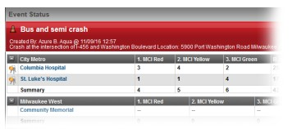
EMResource - Update Event Statuses

Overview: EMResource event statuses allow you to report on situations specific to the type of event. Mass casualty incidents may call for you to report the number of patients by triage category, each of which is represented by a status. It may also be appropriate to report on the availability of equipment or your facility’s decontamination capacity. Events can also help you manage ongoing, non-emergency situations. Facilities
can use a bed availability event to regularly report on the statuses of specific units or types of beds.

To Update Event Statuses:
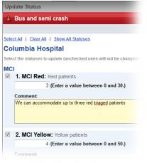
- Click the name of the event in the banner at the top of the page.
- Locate the resource and do one of the following:
  - To update a single status, click its current value.
  - To update multiple statuses at one time, click the resource’s keys icon.
- In the Update Status page, select the check box next to the status you want to update.
- Select or enter the status.
- If appropriate, select the reason for the change.
- If appropriate, in Comment enter a comment on the status change.
- To update additional statuses, repeat steps 3 – 6 for each.
- Click Save.
For more information, contact Juvare Support at 877-771-0911 or support@juvare.com

EMResource - Update Resource Statuses

Overview: A resource is an entity that reports a status. These can be facilities, organizations, and agencies that report information on medical capabilities, services, supplies, and much more. A sub-resource is subordinate to a resource, and it also reports a status. A sub resource to a facility could be a generator or contact. When a change occurs at your location, you or another authorized individual should update your resource’s status in EMResource. This ensures other users at your location and in your region have the most up-to-date resource information.

Updating Statuses: Updating a status involves a couple of steps, including locating the resource or sub-resource and then updating the appropriate status.

To Locate the Resource:
- Point to View and select the appropriate view.
- Locate the resource.
- If the status is available in the View, do one of the following:
  - To update a single status, click its current value.
  - To update multiple statuses at one time, click the resource’s keys icon.
- If the status is not in the view, click the resource’s name to open the View Resource Detail page. Locate the status you want to change and click its value.
To Locate the Sub-resource:
- Point to View and select the appropriate view.
- Locate the resource.
- Click the resource’s name to open the View Resource Detail page.
- Locate the sub-resource’s section and the status you want to change, and do one of the following:
  - To update a single status, click its current value.
  - To update multiple statuses at one time, click the sub resource’s keys icon.
To Update Statuses:
Tip: If you click a status value to update it, you can still view and update all available statuses by selecting the Show All Statuses link in the Update Status page.
- In the Update Status page, select the check box next to the status you want to update.
- Select or enter the status.
- If appropriate, select the reason for the change.
- If appropriate, in Comment enter a comment on the status change.
- To update additional statuses, repeat steps 1 – 4 for each.
- If required to do so, enter your name and password.
- Click Save.

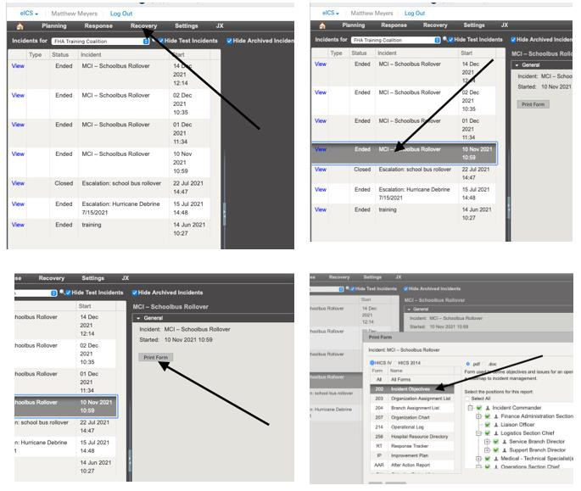
For more information, contact Juvare Support at 877-771-0911 or support@juvare.com

eICS Incident Report 202

In eICS select Recovery tab and then Incident Reports.
- Highlight the incident you created for the exercise.
- Select Print Form
- Select 202
4. Press OK!

APPENDIX E: VOLUNTEER MANAGEMENT PLANS BY
COUNTY

See attached

APPENDIX F: STAGING AREA MAPS
Note: These maps are only for the site’s that cannot have volunteer victims’ stage at their facility. All other hospitals will stage and moulage their volunteer victims at their facility; therefore, do not need bus staging and will not be referenced.

AdventHealth Apopka- TBD

AdventHealth Celebration-TBD

AdventHealth East Orlando- TBD

AdventHealth Kissimmee- TBD

AdventHealth Orlando- TBD

AdventHealth Waterman

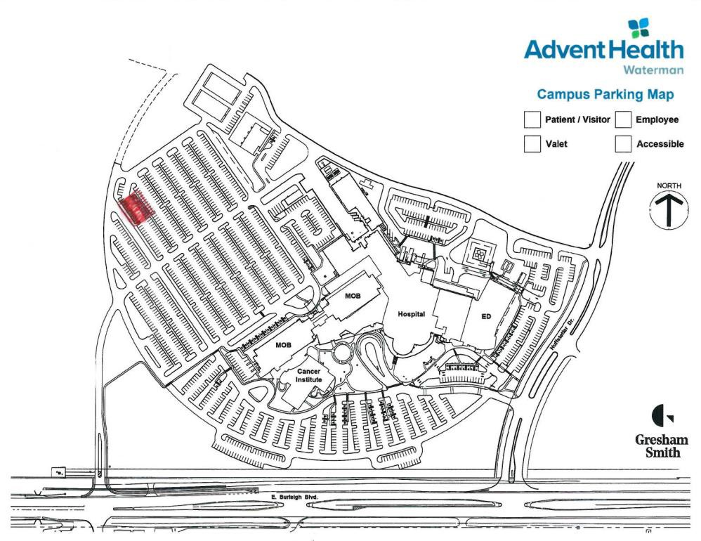

AdventHealth Winter Garden- TBD

AdventHealth Winter Park- TBD

Orlando Health

Arnold & Winnie Palmer Hospital

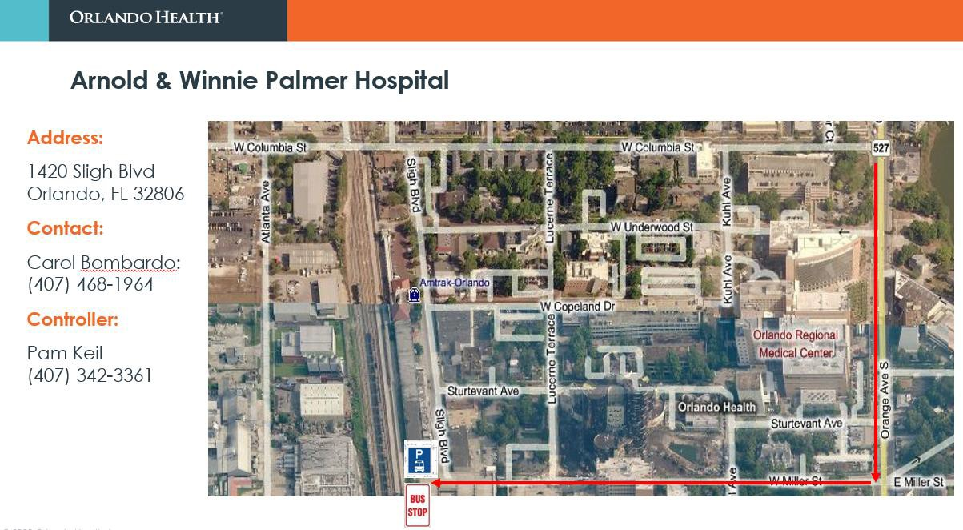

Blue Cedar Freestanding Emergency Department

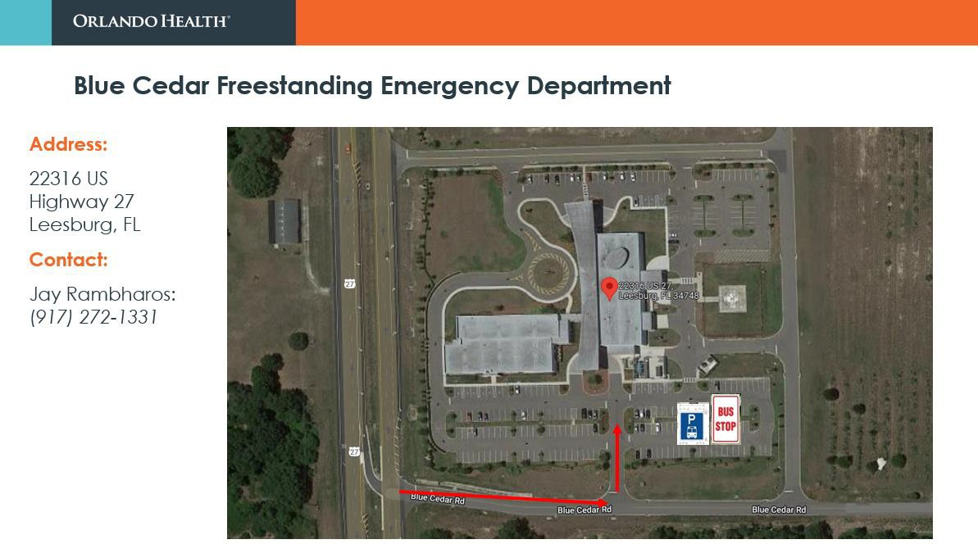

Four Corners Freestanding Emergency Department

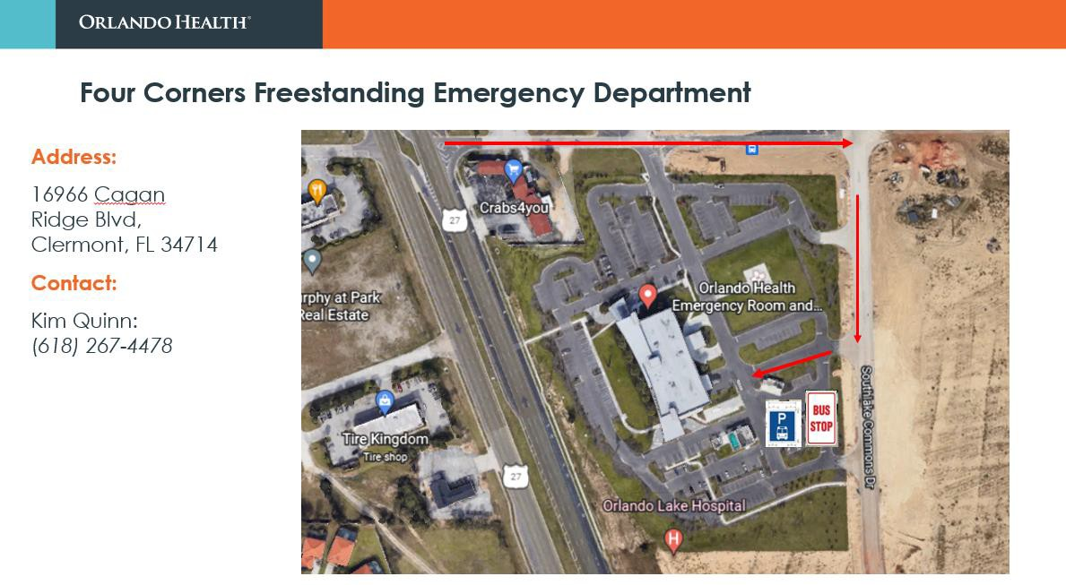

Lake Mary Freestanding Emergency Department

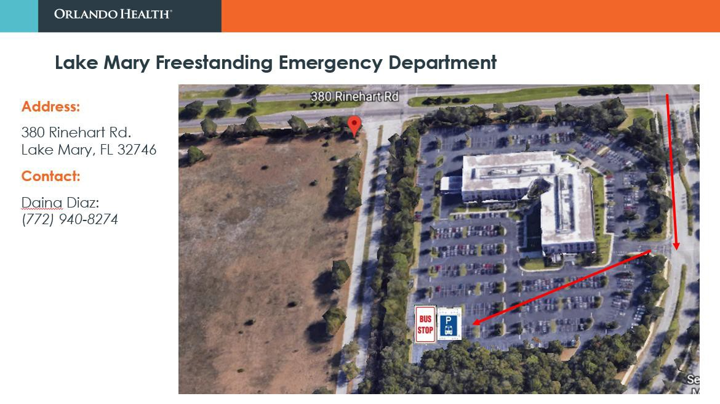

ORMC

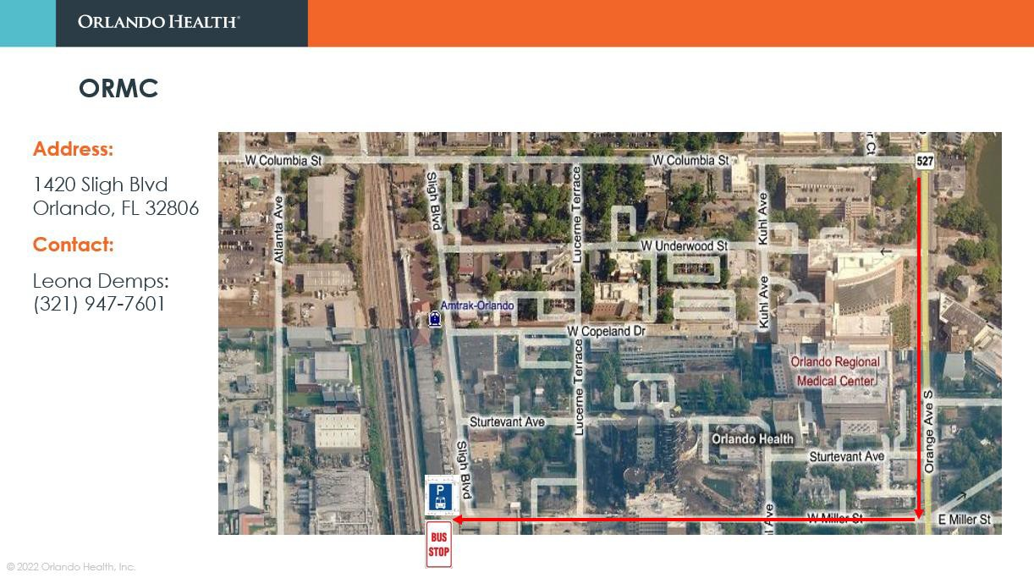

Osceola Freestanding Emergency Department (Pending)

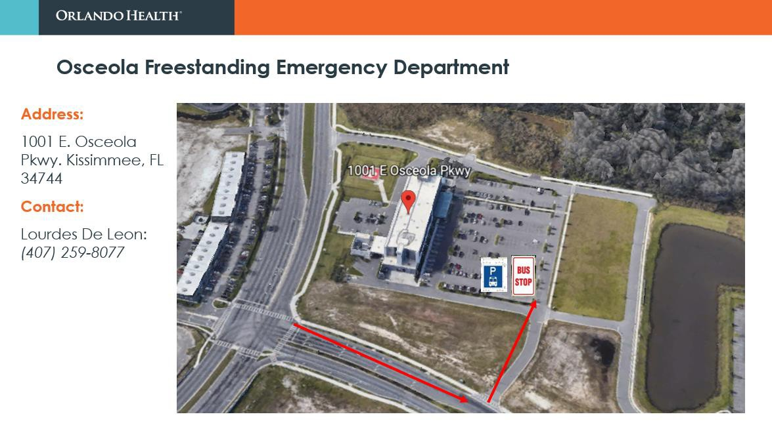

Randall Park Freestanding Emergency Department

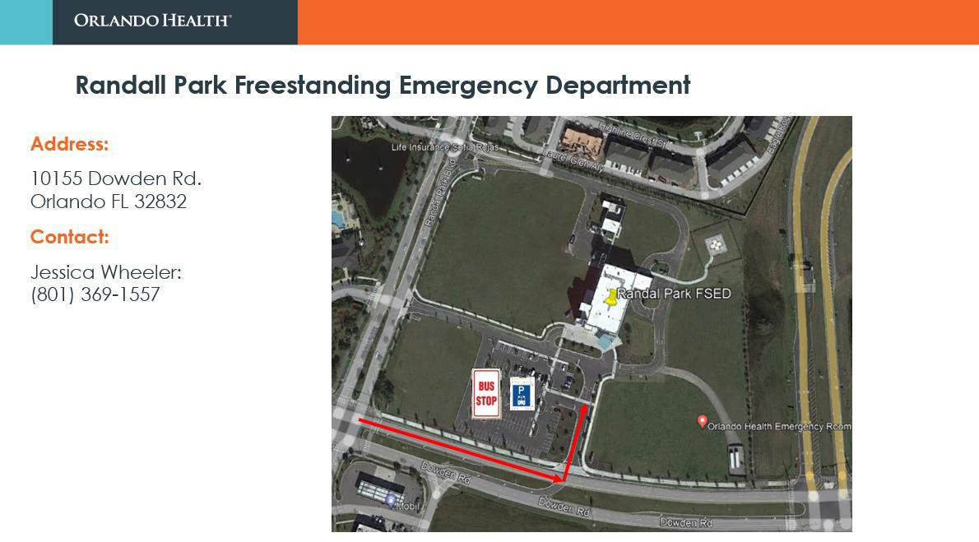

South Lake Hospital

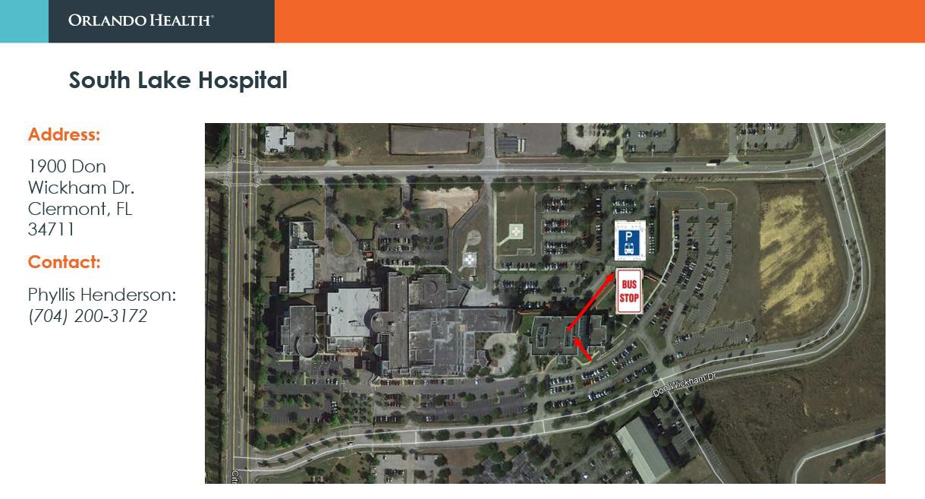

St. Cloud Hospital

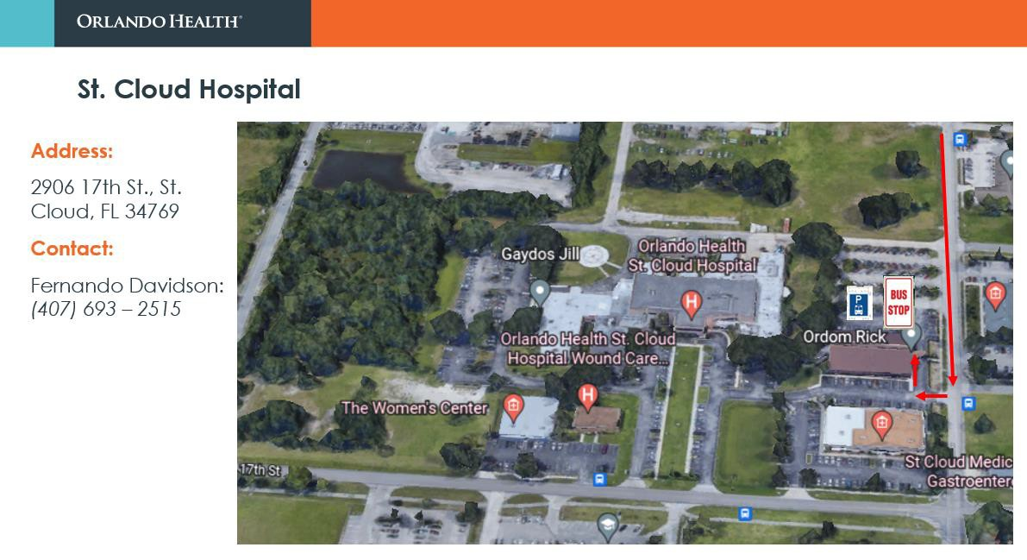

UCF Lake Nona Hospital

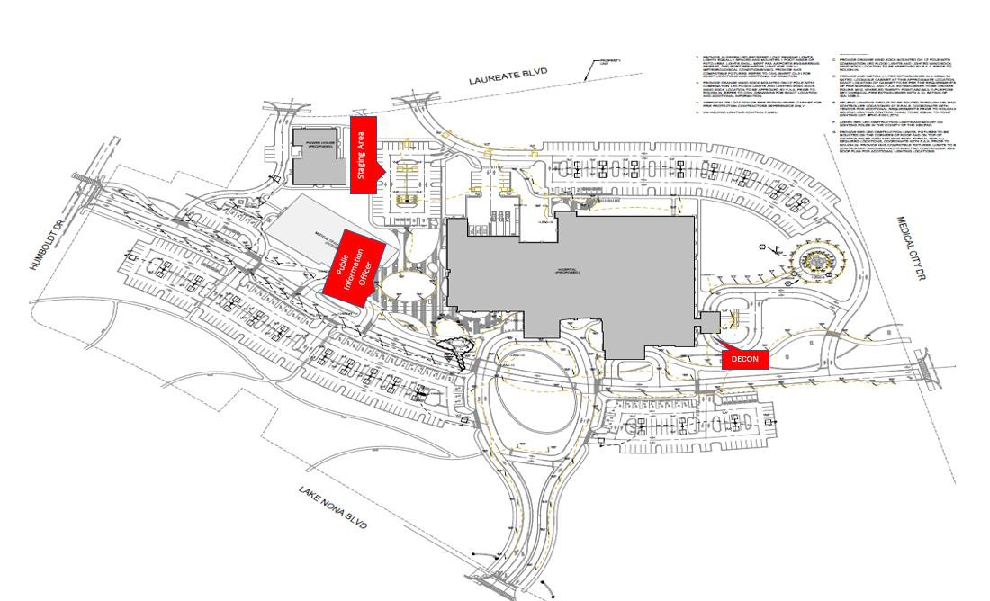

Leesburg High School Campus Map

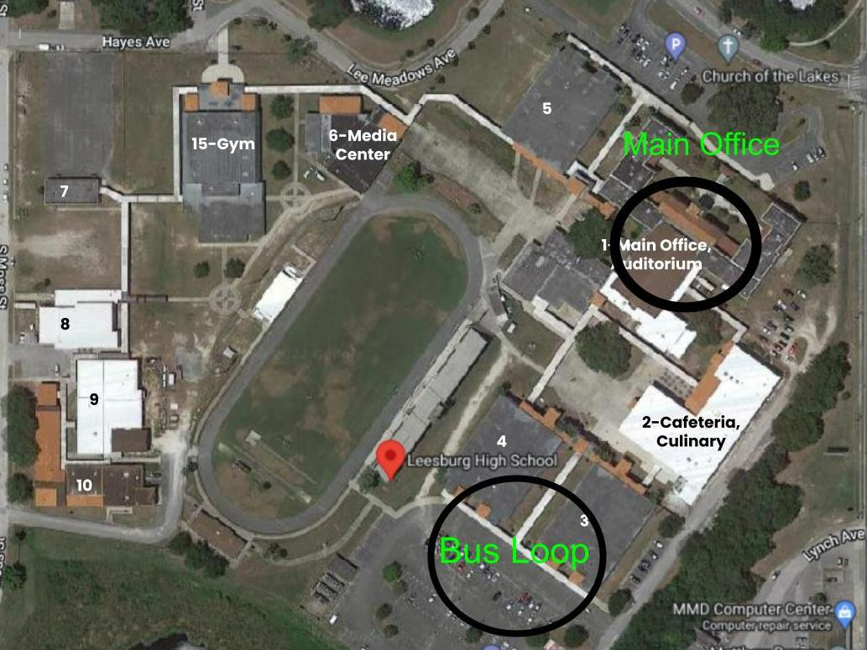

APPENDIX H: EXERCISE EVALUATOR ASSIGNMENTS

**Please reference the attached 2023 Mass Casualty Exercise Evaluator Assignments spreadsheet for hospital Evaluator information**

APPENDIX I: TRIAGE TAGS

Triage Tag – Front (TBD) Triage Tag – Back (TBD)

APPENDIX J: ACRONYMS

Acronym | Term
ASPR | Assistant Secretary for Preparedness & Response
C/E | Controller and Evaluator
CFIX | Central Florida Intelligence Exchange
EEG | Exercise Evaluation Guide
EOC | Emergency Operations Center
EMS | Emergency Medical Services
ESF | Emergency Support Function
ExPlan | Exercise Plan
FBI | Federal Bureau of Investigations
FDLE | Florida Department of Law Enforcement
FBI | Federal Bureau of Investigations
FDLE | Florida Department of Law Enforcement
FSED | Freestanding Emergency Department
HCC | Hospital Command Center
HICS | Hospital Incident Command Center
HPP | Hospital Preparedness Program
HSEEP | Homeland Security Exercise and Evaluation Program
JIS | Joint Information System
MRSE | Medical Response & Surge Exercise
MSEL | Master Scenario Event List
NIMS | National Incident Management System
OCFR | Orange County Fire Rescue
OCPS | Orange County Public Schools
POC | Point of Contact
P&P | Policy & Procedure
SME | Subject Matter Expert
SimCell | Simulation Cell
SOG’s | Standard Operating Guides
SOP’s | Standard Operating Procedures

